**Jenkins for Cypress:**

**Step 1:** Download Jenkins as a war file from the link <https://www.jenkins.io/download/>

**Step2:** use the war file from LTS as highlighted to install

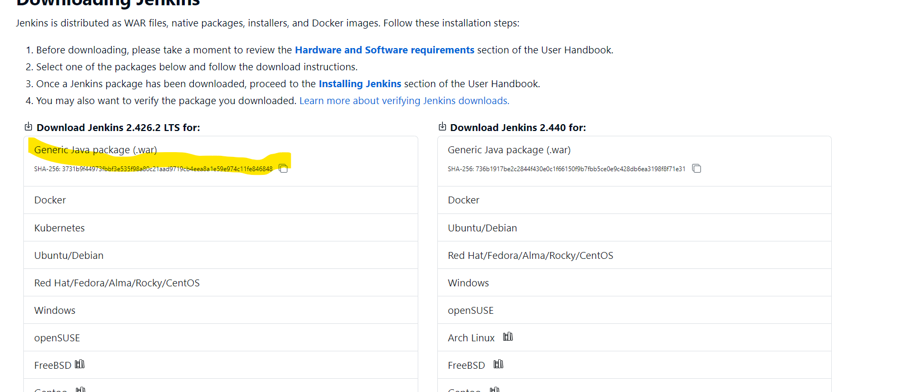

**Step3:** save the war file in a accessible location and open command prompt and run the below command

java -jar Jenkins.war

**NOTE:**

In case if any errors while installation and if the errors has “port number” or ”bind” then we need to allocate another port to the Jenkins(Default port number is 8080 use anything apart from this)

Example:

java - jar jenkins.war --httpsPort=8089

If it’s exe skip this command prompt steps and continue to run the exe and launch [**http://localhost:8080**](http://localhost:8080)

**In case if post number is changed provide the right port number.**

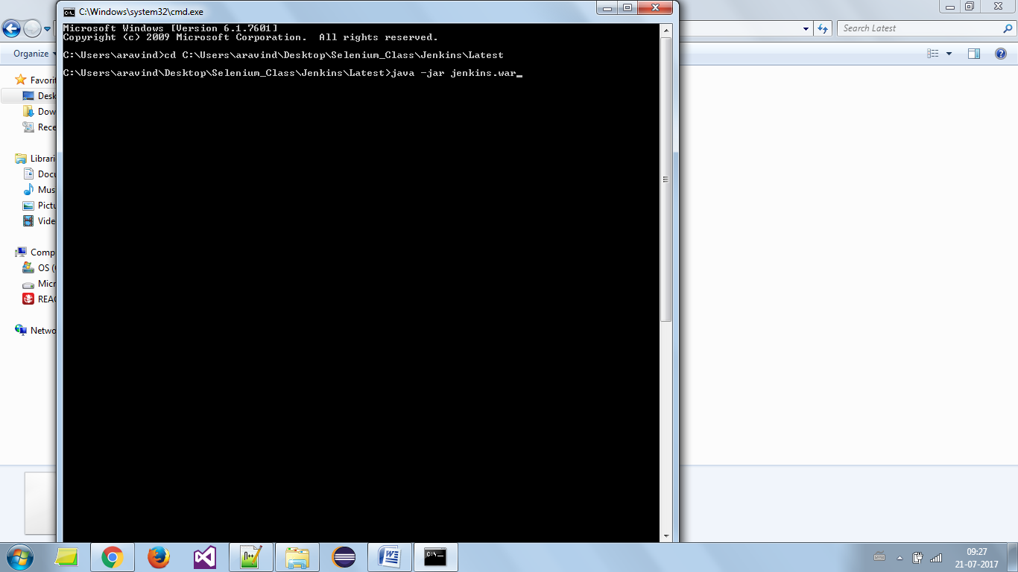

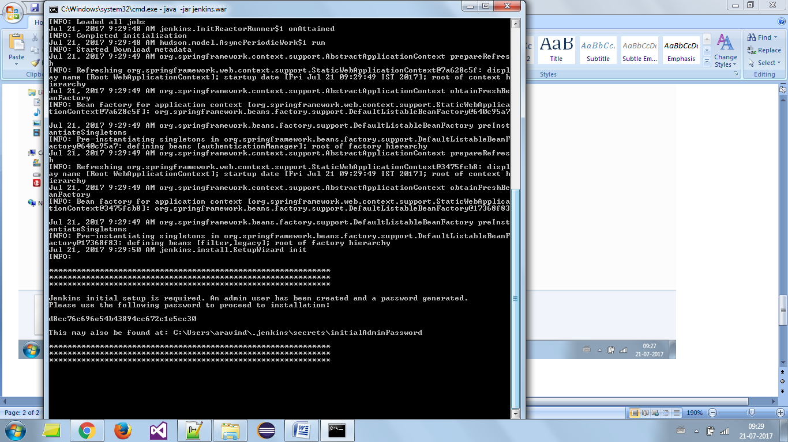

**Step4:**

Please note the password self generated by the Jenkins to provide it for initial login

Once done ,

Use the default link [**http://localhost:8080**](http://localhost:8080) and use the password generated to login,

Incase if you change the default port number use [**http://localhost:portnumber**](http://localhost:portnumber)

**Step5:**

Now use the link https:localhost:8080 or replace the port number by the port number that you have specified during installation

Navigate the screens as below,

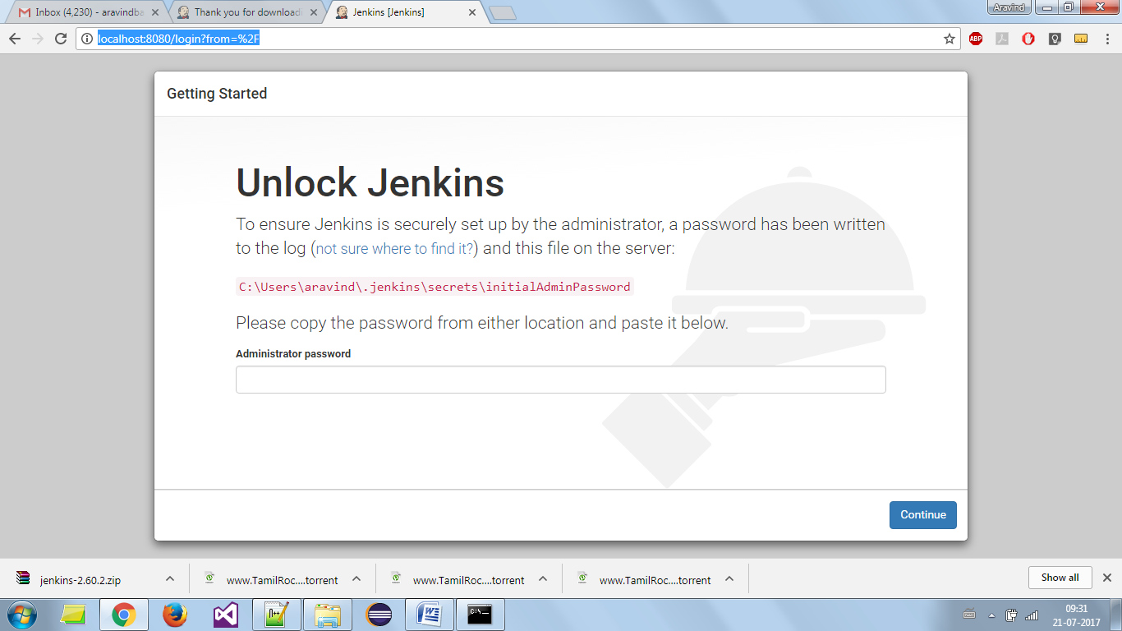

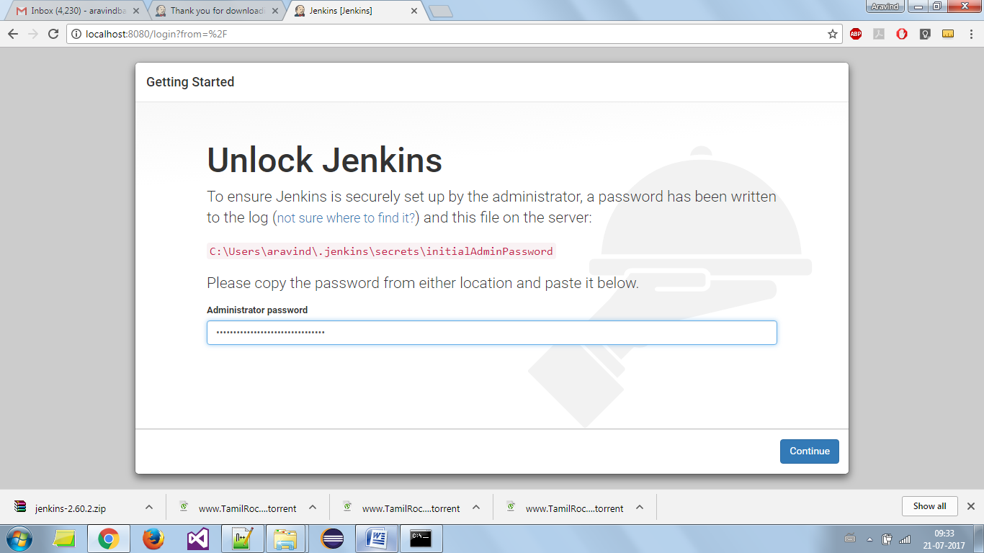

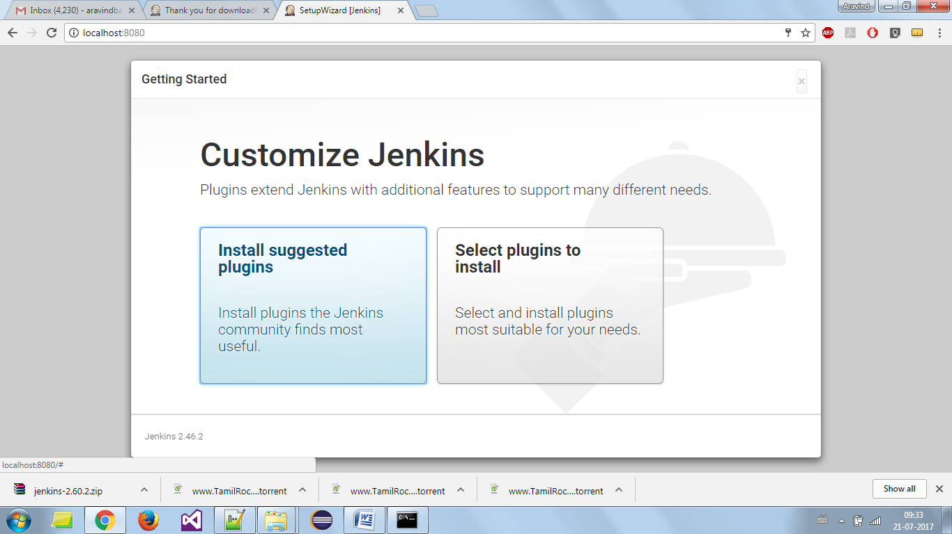

Select install suggested plugin, it takes up couple of minutes to install the default plugins

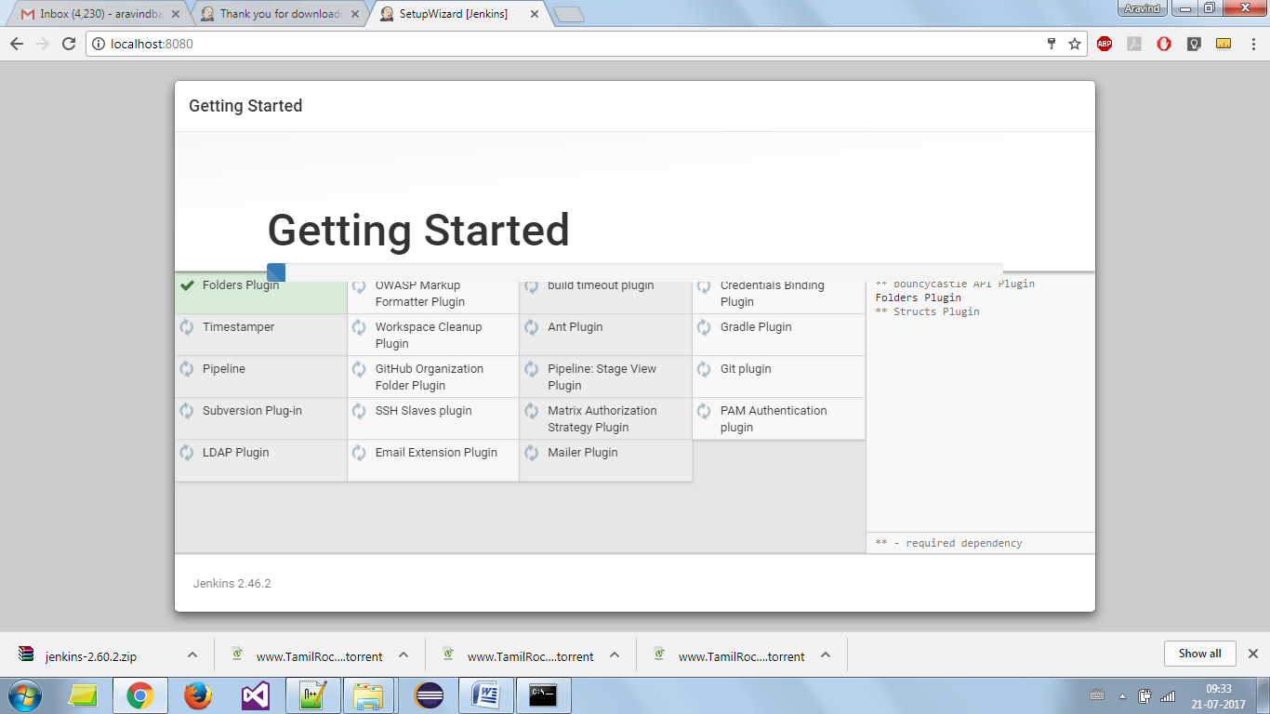

Once installed it will ask for new username and password to login for next time,

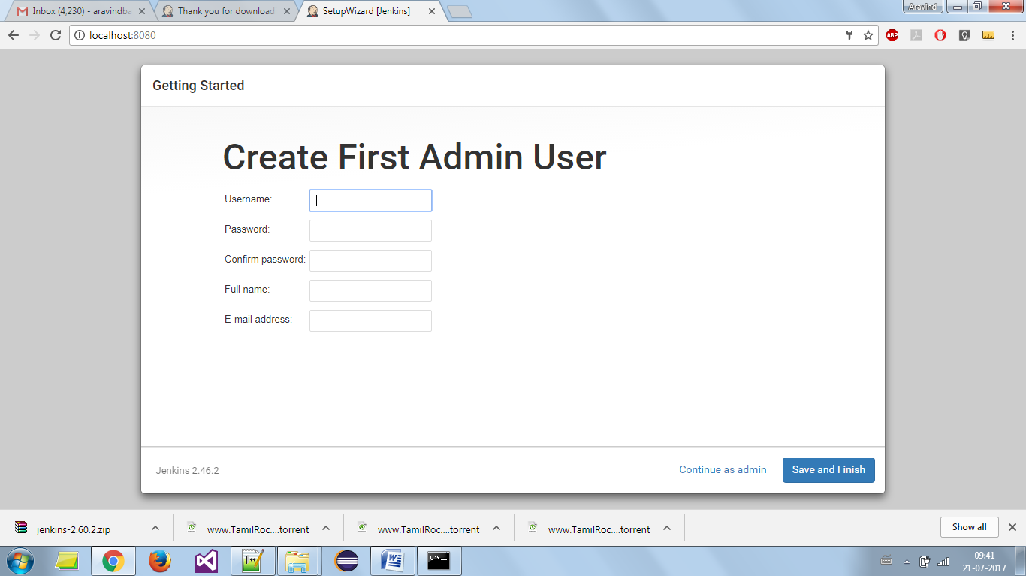

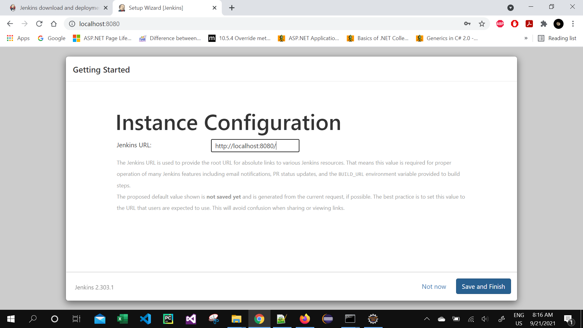

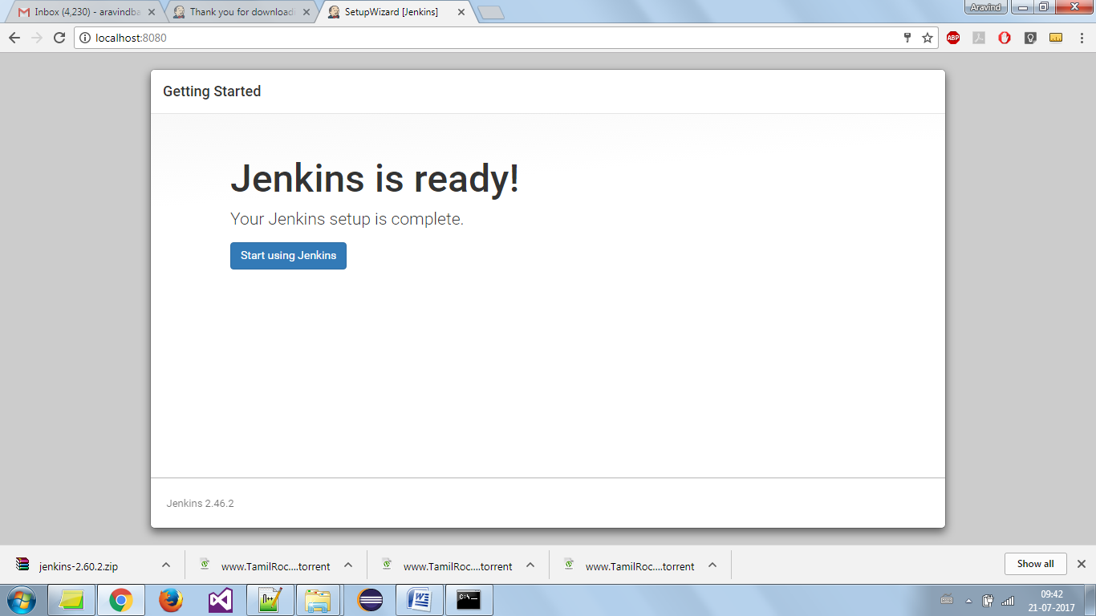

**Step6:**

Now we need to download the nodejs from the below navigation

Dashboard 🡪 Manage Jenkins🡪 plugins 🡪 Available Plugins 🡪 search for “nodejs” and click on check box and install

**Step7:**

Now setup nodejs as global in Jenkins

Dashboard 🡪 Manage Jenkins🡪 Tools 🡪 NodeJS Installation section 🡪 choose the version of the nodejs required under version and mention any specific version of the cypress we want to install under “Global npm packages to install” like below

[cypress@13.6.2](mailto:cypress@13.6.2) 🡪 example

Then save and apply

**Step8:**

Now create a new job for Jenkins Dashboard by clicking the “New Item”

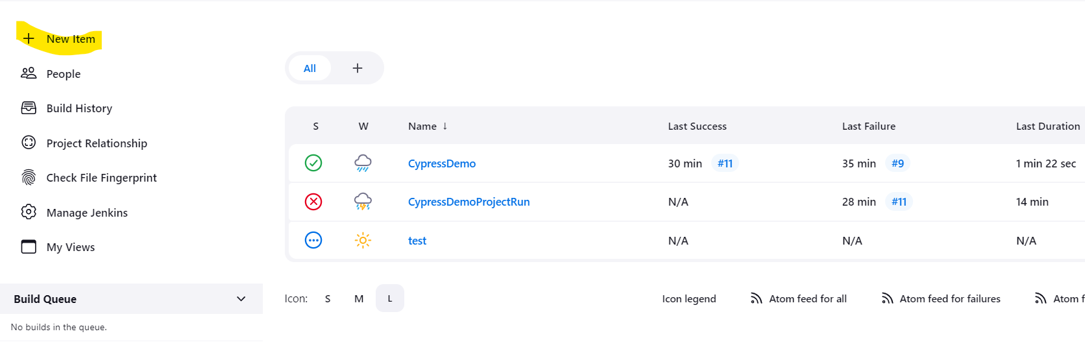

**Step9:**

Now click the “Free Style project” and provide a suitable name and click ok

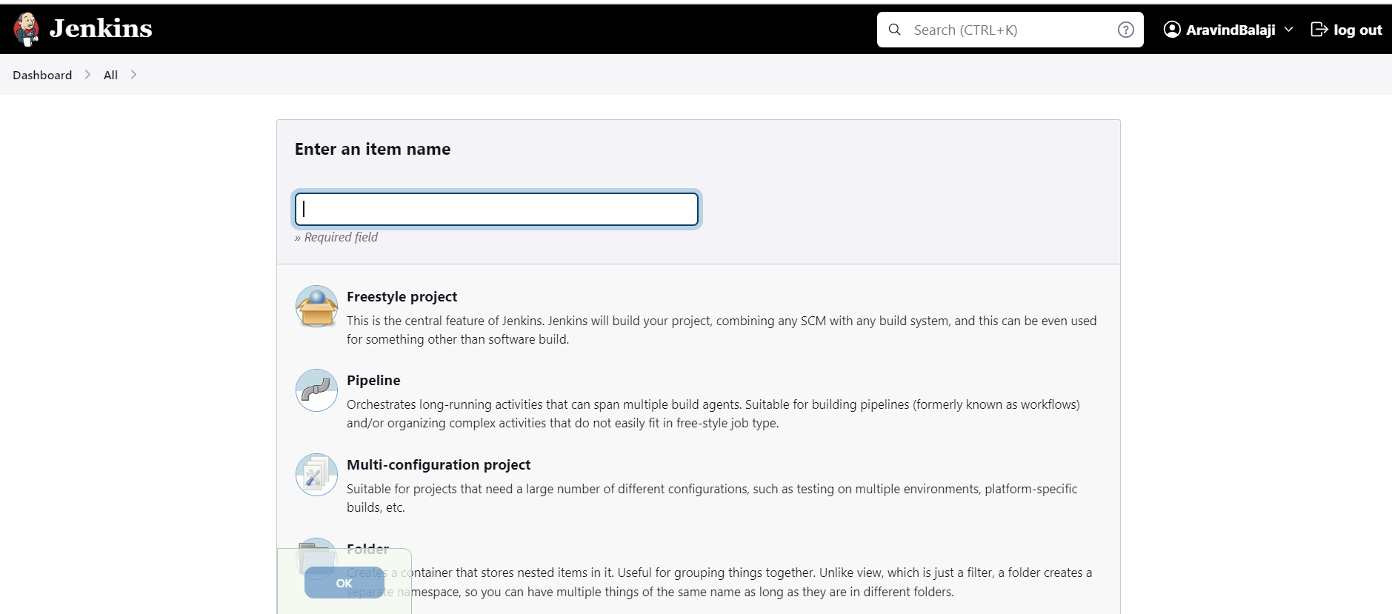

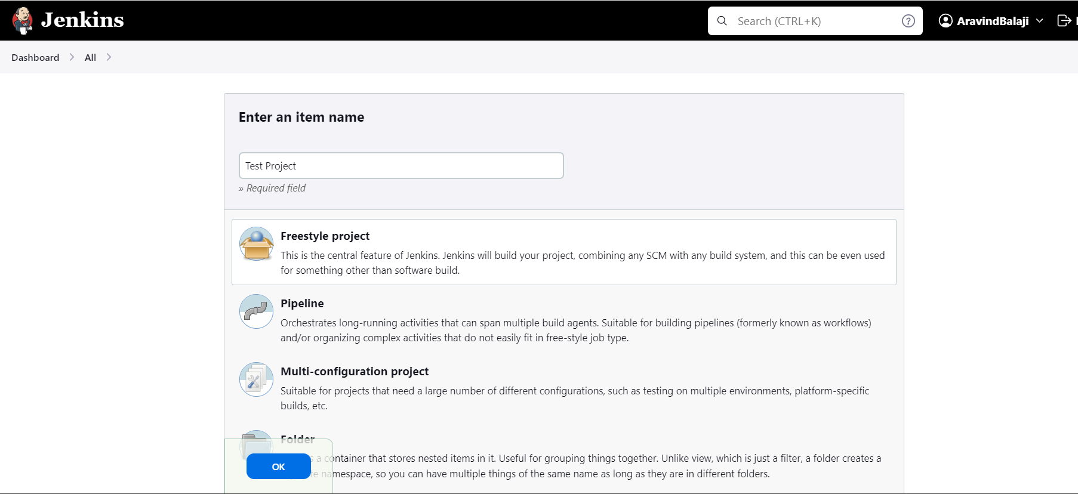

**Step10:**

Now follow the below steps

Under “**Source Code Management**” select git and provide the git url path

For credentials use the git username and personal access token created from git

As shown below ,

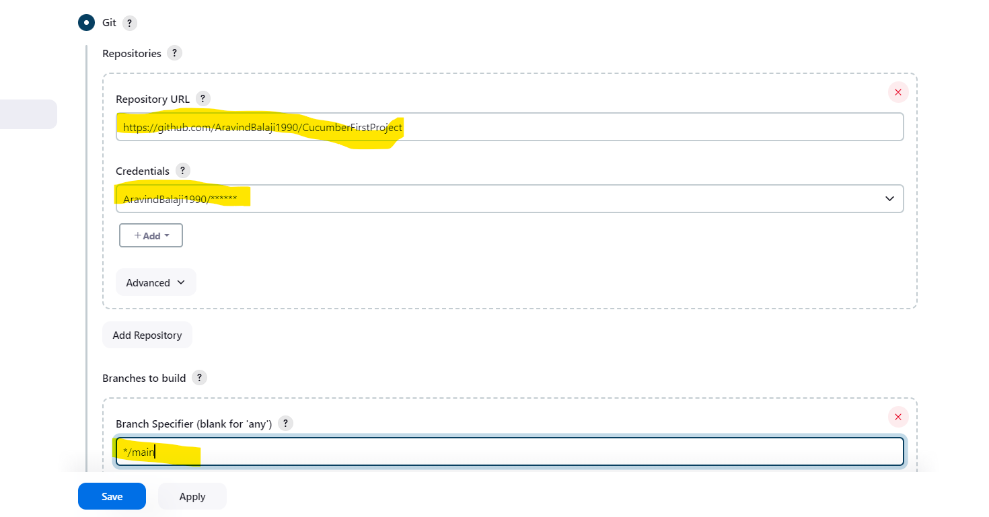

**Step11:**

Under the “**Build Steps**” we need to choose accordingly to the OS it runs

Windows/mac 🡪 Execute windows batch command

Linux 🡪 Execute shell

Then provide the cypress command to run the project

Example as shown in screenshot

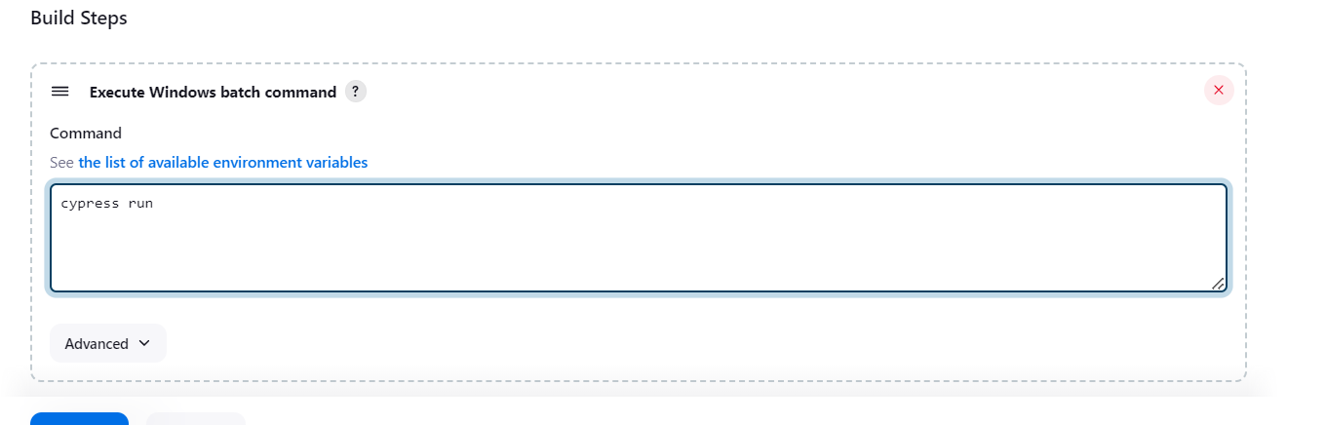

**Step12:**

Apply and save then click on build now to trigger the build 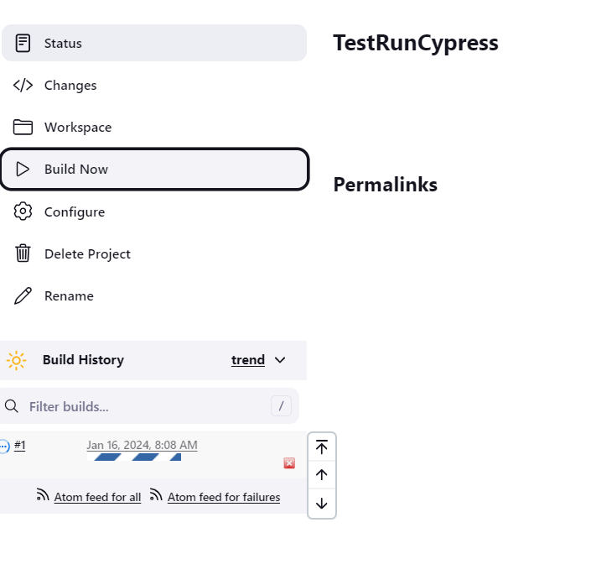

**Step13:**

Click on the build number to check the console output or the running logs

